Healthcare Data Analysis
1.Project overview
The Healthcare Data Analysis project focuses on extracting insights from healthcare data to improve decision-making and efficiency. The dataset includes patients, doctors, treatments, and billing information. Data cleaning was performed using SQL, analysis in Excel, and visualization in Power BI dashboards. The project highlights trends in patient demographics, disease patterns, and hospital performance.

2.Objectives
- To clean and preprocess healthcare data
- To perform data analysis using SQL
- To analyze trends using Excel
- To create dashboards using Power BI
- To derive insights for decision-making

3.Dataset summary
- Rows: ~55,000
- Columns: 17
- Key Features:
  - Patient demographics (Name, Age, Gender, Blood Type)
  - Medical information (Medical Condition, Test Results, Medication)
  - Admission details (Admission Date, Discharge Date, Admission Type, Room Number, Length of Stay)
  - Hospital details (Doctor Name, Hospital Name)
  - Insurance information (Insurance Provider)
  - Financial data (Billing Amount)

4.Tools and Technologies Used
- SQL → Data cleaning and querying
- Microsoft Excel → Data analysis and pivot tables
- Power BI → Dashboard and visualization

5.Data Cleaning Process (Excel)
Data cleaning was performed in Microsoft Excel to ensure data accuracy and consistency. The following steps were carried out:
- Removed duplicate records
- Handled missing values
- Corrected name errors and inconsistencies
- Standardized data formats (dates and text fields)
- Verified numerical values such as billing amount

6.SQL Analysis
The following SQL queries were performed to analyze the dataset:
6.1 Overall Dataset Analysis
- Calculated total number of patients
- Computed average billing amount
- Calculated average length of stay
Purpose: To understand overall dataset trends and averages.

6.2 Admission Type Analysis
- Grouped data by admission type
- Counted number of patients in each category
- Calculated average billing and average stay
Purpose: To compare emergency, urgent, and elective admissions.

6.3 Medical Condition Analysis
- Calculated average billing for each medical condition
- Identified top 5 conditions with highest cost
Purpose: To analyze expensive treatments and disease patterns.

6.4 Hospital Analysis
- Compared hospitals based on average length of stay
- Analyzed average billing amount per hospital
Purpose: To evaluate hospital performance and efficiency.
7. Data Visualization (Power BI)
Interactive dashboards were created using Power BI to represent the data visually. The dashboard includes:
- Patient distribution by age and gender
- Analysis of medical conditions
- Admission type comparison
- Billing amount trends
- Hospital performance insights

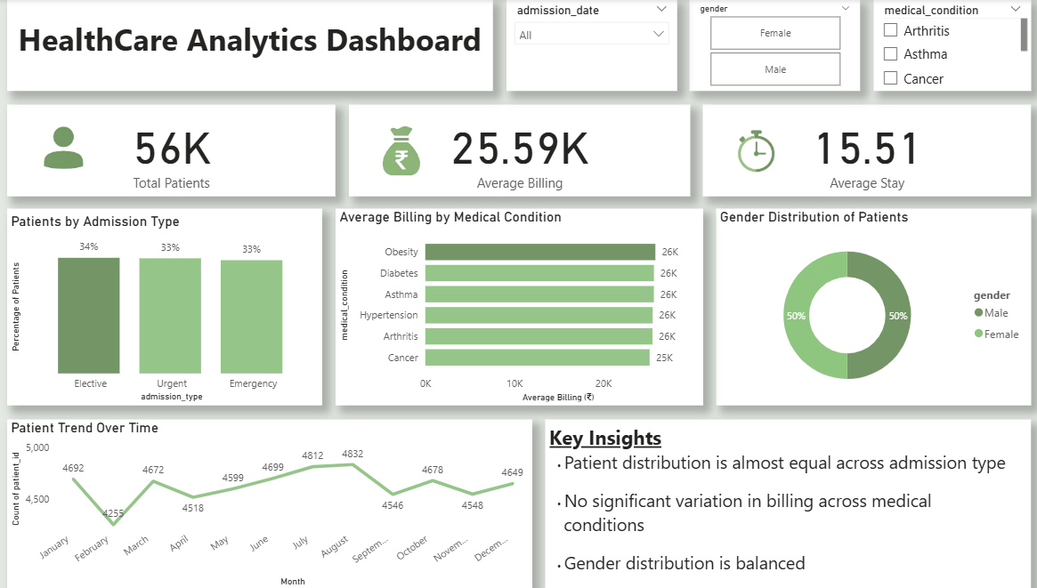

8. Business Recommendations
- Optimize High-Cost Treatments - Review expensive treatments to reduce costs and improve efficiency.
- Improve Emergency Services Management - Allocate resources effectively for emergency and urgent cases.
- Enhance Hospital Performance - Monitor and reduce patient stay duration for better efficiency.
- Promote Preventive Healthcare - Focus on early diagnosis and prevention of common diseases.
- Strengthen Financial Planning - Analyze billing data to control costs and improve revenue.
- Use Data-Driven Decision Making - Utilize analytics tools to improve overall hospital operations.

